Endoscopic Resection of the Oesophagus and Oesophagogastric Junction Histopathology Reporting Guide

Elements in black text are CORE Elements in grey text are NON-CORE o indicates single select values □ indicates multi-select values

Definition of Core elements | Core elements are those which are essential for the clinical management, staging or prognosis of the cancer. These elements will either have evidentiary support at Level III-2 or above (based on prognostic factors in the National Health and Medical Research Council (NHMRC) levels of evidence¹). In rare circumstances, where level III-2 evidence is not available an element may be made a core element where there is unanimous agreement by the Dataset Authoring Committee (DAC). An appropriate staging system, e.g., Pathological TNM staging, would normally be included as a core element. Non-morphological testing e.g., molecular or immunohistochemical testing is a growing feature of cancer reporting. However, in many parts of the world this type of testing is limited by the available resources. In order to encourage the global adoption of ancillary tests for patient benefit, International Collaboration on Cancer Reporting (ICCR) recommends that some ancillary testing in ICCR Datasets is included as CORE elements. Where the technical capability does not yet exist, laboratories may consider temporarily using these data elements as NON-CORE items.The summation of all core elements is considered to be the minimum reporting standard for a specific cancer.  Reference  1 Merlin T, Weston A and Tooher R (2009). Extending an evidence hierarchy to include topics other than treatment: revising the Australian 'levels of evidence'. BMC Med Res Methodol 9:34.
Definition of Non-core elements | Non-core elements are those which are unanimously agreed should be included in the dataset but are not supported by level III-2 evidence. These elements may be clinically important and recommended as good practice but are not yet validated or regularly used in patient management.  Key information other than that which is essential for clinical management, staging or prognosis of the cancer such as macroscopic observations and interpretation, which are fundamental to the histological diagnosis and conclusion e.g., macroscopic tumour details, may be included as either core or non-core elements by consensus of the DAC.
Scope of this dataset | The dataset has been developed for the pathology reporting of endoscopic resection (ER) of pre-malignant and malignant lesions of the oesophagus and oesophagogastric junction (OGJ). Surgically resected specimens are covered in a separate (ICCR dataset.¹  Neuroendocrine carcinomas (NEC) and mixed neuroendocrine-non-neuroendocrine neoplasms (MiNEN) of the oesophagus are included.  Neuroendocrine tumours (NET), non-epithelial malignancies such as melanoma, and secondary tumours are excluded from this dataset.  Reference  1 International Collaboration on Cancer Reporting (2021). Carcinoma of the Oesophagus Histopathology Reporting Guide, 2nd Edition. Available from: http://www.iccr-cancer.org/datasets/published-datasets/digestive-tract/carcinoma-of-the-oesophagus (Accessed 20th December 2021).

Core/  Non-core | Element name | Values | Commentary | Implementation notes
Non-core | CLINICAL INFORMATION | - Information not provided  - Relevant biopsy results, specify  - Previous diagnosis and treatment for oesophageal cancer, specify  - Endoscopic location of the tumour, specify levels  (upper/middle/lower)  - Clinical staging, specify level of involvement  - History of gastroesophageal reflux and/or Barrett  oesophagus  - Other (e.g., previous history of cancer), specify | Clinical information should ideally be provided by the clinician on the endoscopy report or the pathology request form. Pathologists may also search for additional information from previous pathology reports.  Relevant biopsy results include the presence of carcinoma, dysplasia (intraepithelial neoplasia) and Barrett metaplasia.  Endoscopic location and information regarding the location of the tumour are an important guide to the actual anatomical location and thus the staging of the tumour. In addition, the depth of the invasion of early oesophageal cancer can be predicted with some accuracy by endoscopic appearance.¹  Multiple tumours can occur in the oesophagus and especially in patients with a previous history of cancer, e.g., carcinoma of hypopharynx.  Reference  1 Maes S, Haidry R and Bisschops R (2018). Can the depth of invasion of early esophageal cancer be predicted based on endoscopic evidence? Minerva Chir 73(4):385-393.
Core | ENDOSCOPIC PROCEDURE | - Not specified  - Endoscopic mucosal resection (EMR)  - Endoscopic submucosal dissection (ESD)  - Other, specify | ER is indicated in many early oesophageal cancers. Generally, ER for oesophageal cancer is limited to dysplasia and superficial mucosal cancers, whereas surgery is recommended for those with deep mucosal or submucosal invasion.  EMR is usually undertaken for mucosal lesions.¹ The complication rate for perforation for EMR is less than 2%.¹  ESD involves dissecting the submucosa to remove a larger oesophageal cancer and is technically more challenging. It allows for resection of lesions of much larger size but with higher complication rate.^{2,3}  On pathological examination of a biopsy of early cancer, the presence of lymphovascular invasion, submucosal invasion, and poor tumour differentiation favour surgical treatment.⁴  References  1 Zhang YM, Boerwinkel DF, Qin X, He S, Xue L, Weusten BL, Dawsey SM, Fleischer DE, Dou LZ, Liu Y, Lu N, Bergman JJ and Wang GQ (2016). A randomized trial comparing multiband mucosectomy and cap-assisted endoscopic resection for endoscopic piecemeal resection of early squamous neoplasia of the esophagus. Endoscopy 48(4):330-338.  2 Yamamoto H, Kawata H, Sunada K, Sasaki A, Nakazawa K, Miyata T, Sekine Y, Yano T, Satoh K, Ido K and Sugano K (2003). Successful en-bloc resection of large superficial tumors in the stomach and colon using sodium hyaluronate and small-caliber-tip transparent hood. Endoscopy 35(8):690-694.  3 Kim JS, Kim BW and Shin IS (2014). Efficacy and safety of endoscopic submucosal dissection for superficial squamous esophageal neoplasia: a meta-analysis. Dig Dis Sci 59(8):1862-1869.  4 Simic AP, Skrobic OM and Pesko PM (2019). A surgeon's role in the management of early esophageal, EGJ and gastric lesions. Dig Dis 37(5):355-363.
Core | SPECIMEN DIMENSIONS | ___ mm x ___ mm x ___ mm  ___ mm x ___ mm x ___ mm  - Cannot be assessed, specify | When the specimens are received piecemeal, they should be reconstructed for measurement purposes, if possible. The ICCR Oesophagus Endoscopic Resection Dataset Authoring Committee recommended that the reporting of specimen dimensions should be a core element. | Record per specimen.
Non-core | MACROSCOPIC APPEARANCE | - No macroscopically detectable lesion  - Polypoid  - 0-Ip (protruded, pedunculated)  - 0-Is (protruded, sessile;  >2.5 mm above baseline)  - Non-polypoid  - 0-IIa (superficial, elevated; <2.5 mm above baseline)  - 0-IIb (flat)  - 0-IIc (superficial shallow, depressed)  - 0-III (excavated/ulcerated) | There is no evidence that macroscopic appearance has prognostic value in oesophageal cancer. However, the macroscopic appearance of the lesion, such as having an ulcerative appearance, could indicate the potential for a more advanced lesion.  The pathologist could also refer to the endoscopic appearance, if available, to compare the morphology (Figures 1 and 2).  An intramucosal cancer generally has a flat appearance (Paris Classification 0-IIa, 0-IIb,). By contrast, a submucosally invasive cancer often has an excavated appearance (Paris Classification 0-IIc, 0-III) and sometimes polypoid morphology (Paris Classification 0-I).¹  In squamous cell carcinoma of the oesophagus, classification of surface vessels and intrapapillary capillary loops by endoscopic appearance also allows for accurate assessment of invasion depth.^{2,3}  Figure 1-2 (See end of document for figures)  References  1 Participants in the Paris Workshop (2003). The Paris endoscopic classification of superficial neoplastic lesions: esophagus, stomach, and colon: November 30 to December 1, 2002. Gastrointest Endosc 58(6 Suppl):S3-43.  2 Inoue H, Kaga M, Ikeda H, Sato C, Sato H, Minami H, Santi EG, Hayee B and Eleftheriadis N (2015). Magnification endoscopy in esophageal squamous cell carcinoma: a review of the intrapapillary capillary loop classification. Ann Gastroenterol 28(1):41-48.  3 Sharma P, Shaheen NJ, Katzka D and Bergman J (2020). AGA clinical practice update on endoscopic treatment of Barrett's esophagus with dysplasia and/or early cancer: expert review. Gastroenterology 158(3):760-769.
Core | TUMOUR FOCALITYª | - Unifocal  - Multifocal, specify number of tumours in specimen  - Cannot be assessed, specify | Multifocal oesophageal carcinomas should be documented. If there are synchronous primary lesions (i.e., two or more individual tumours), separate datasets should be used to record the tumour site and all following elements for each primary tumour. | ª If multiple primary tumours are present, separate datasets should be used to record this and all following elements for each primary tumour.
Core and Non-core | TUMOUR SITE | - Not specified  - Cervical (proximal) oesophagus  - Upper thoracic oesophagus  - Middle thoracic oesophagus  - Lower thoracic (distal) oesophagus  - OGJ with tumour epicentre ≤20 mm into the proximal stomach  - Other, specify  Distance from epicentre/midpoint of tumour to OGJ ___mm | The location of the tumour is important for staging of oesophageal cancer.¹  The location of a tumour is based on endoscopic examination and landmarks. Therefore, clinical information provided by surgeon or endoscopist is critical.  The anatomical subdivisions of the oesophagus are outlined below and in Figure 3:¹  - The cervical oesophagus begins at the hypopharynx and extends to the thoracic inlet (at the level of the sternal notch); 150 to <200 millimetres (mm) from the incisors.  - Upper thoracic oesophagus extends from the thoracic inlet to the lower border of the azygos vein; 200 to <250 mm from the incisors.  - Middle thoracic oesophagus extends from the lower border of the azygos vein to the lower border of the inferior pulmonary vein; 250 to <300 mm from the incisors.  - Lower thoracic (distal) oesophagus extends from the lower border of the inferior pulmonary vein to the stomach, including the abdominal oesophagus; 300-400 mm from the incisors.  - Upper oesophagus is equal to cervical oesophagus and upper thoracic oesophagus.  - Middle oesophagus is equal to middle thoracic oesophagus.  - Lower oesophagus is equal to lower thoracic oesophagus or distal oesophagus.  Figure 3 (See below document for figure)  A description of the tumour site is ideally provided by the surgeon and should be documented by the pathologist. In addition, specific observations should be recorded by the pathologist which may help establish the exact site of origin of the tumour.  The American Joint Committee on Cancer (AJCC) and College of American Pathologists (CAP) define the OGJ as the junction of the tubular oesophagus and the stomach, irrespective of the type of epithelial lining of the oesophagus.^{1,2}  Pure anatomical classification of the tumour site of origin can be defined in several different systems. The Siewert Classification categorises OGJ cancer into Siewert type I (tumours with their epicentre located 10-50 mm above the OGJ), type II (tumour epicentre located from 10 mm above to 20 mm below the OGJ) and type III (tumour epicentre located from 20 mm - 50 mm below the OGJ).³ In the Siewert Classification, the proximal end of the gastric longitudinal mucosa folds is used as pragmatic reference for the endoscopic cardia/OGJ (zero point).³ The current Union for International Cancer Control (UICC)⁴/AJCC¹ 8th edition Staging Systems definition of gastric cancer includes those tumours involving the OGJ but with the epicentre >20 mm into the proximal stomach and cardia cancer without involvement of the OGJ.¹ Therefore, all Siewert type III tumours are classified as gastric cancer based on the UICC⁴/AJCC¹ 8th edition Staging Systems.  The UICC⁴/AJCC¹ 8th edition Staging Manuals also define tumours involving the OGJ as those with a midpoint within the proximal 20 mm of the cardia/proximal stomach and are staged as oesophageal cancers. In contrast, tumours involving the OGJ with their epicentre more than 20 mm into the cardia/proximal stomach are staged as stomach cancers, as are all cardia/proximal stomach cancers not involving the OGJ, even if within 20 mm of the OGJ.  Some proximal stomach tumours which appear to be of gastric origin, under the AJCC 8th edition Classification,¹ may be classified as tumours of the oesophagus and OGJ somewhat artificially and thus reported using the oesophageal dataset. When reporting such tumours, it should be noted that the tumour may have arisen within the stomach.  References  1 Amin MB, Edge SB, Greene FL, Byrd DR, Brookland RK, Washington MK, Gershenwald JE, Compton CC, Hess KR, Sullivan DC, Jessup JM, Brierley JD, Gaspar LE, Schilsky RL, Balch CM, Winchester DP, Asare EA, Madera M, Gress DM and Meyer LR (eds) (2017). AJCC Cancer Staging Manual. 8th Edition, Springer, New York.  2 Protocol for the examination of specimens from patients with carcinoma of the esophagus (2021). Protocol for the examination of specimens from patients with carcinoma of the esophagus. Available from: https://documents.cap.org/protocols/Esophagus_4.2.0.0.REL_CAPCP.pdf (Accessed 4th November 2021).  3 Stein HJ, Feith M and Siewert JR (2000). Cancer of the esophagogastric junction. Surg Oncol 9(1):35-41.  4 Brierley JD, Gospodarowicz MK and Wittekind C (eds) (2016). Union for International Cancer Control. TNM Classification of Malignant Tumours, 8th Edition, Wiley, USA.
Core and Non-core | TUMOUR DIMENSIONS | Maximum tumour dimension  ___ mm  Additional dimensions  ____ mm x____ mm  - No macroscopically visible tumour  - Cannot be assessed, specify | Where possible, the pathologist should record the maximum longitudinal dimension of the tumour mass and the distance of the tumour midpoint from the OGJ in the oesophagus and in the stomach.  If no tumour is macroscopically visible, or for small tumours where the macroscopic dimensions may not be accurate, then the microscopic dimensions should be documented.  If the specimen is fragmented, measurements of the reconstructed tumour should be estimated, where possible. Otherwise, the clinical and/or radiological measurements should be used.
Non-core | BARRETT MUCOSA | - Not identified  - Present | The presence of Barrett mucosa points to the aetiology of the adenocarcinoma and helps to differentiate the origin of the lesion i.e., oesophageal versus gastric. The definition of Barrett mucosa varies between countries. In many regions, the presence of goblet cells is required for a diagnosis of Barrett mucosa.
Core | HISTOLOGICAL TUMOUR TYPE | - Cannot be assessed  - Oesophageal glandular dysplasia, low grade  - Oesophageal glandular dysplasia, high grade  - Oesophageal squamous dysplasia, low grade  - Oesophageal squamous dysplasia, high grade  - Squamous cell carcinoma  - Conventional  - Verrucous  - Spindle cell carcinoma  - Basaloid squamous cell carcinoma  - Adenocarcinoma  - Tubular  - Papillary  - Mucinous  - Poorly cohesive carcinoma  - Signet ring  - Non-signet ring  - Mucoepidermoid  - Adenosquamous carcinoma  - Adenoid cystic carcinoma  - Undifferentiated carcinoma  - Neuroendocrine neoplasms^{b}  - Neuroendocrine carcinoma  - Small cell  - Large cell  - MiNEN  - Other, specify | Pathological staging is different for the two major groups of oesophageal carcinomas, adenocarcinoma and squamous cell carcinoma.^{1,2} It is important to refer to the current World Health Organization (WHO) Classification of Tumours of the Digestive System, 5th edition, 2019 for the different oesophageal malignant neoplasms (Table 1).³ The ICCR dataset includes 5th edition Corrigenda, September 2022.⁴  Adenoid cystic carcinoma, undifferentiated carcinoma or MiNEN (the neuroendocrine component is nearly always NEC) with an adenocarcinoma component, follow the adenocarcinoma stage grouping.⁵ There is no definite evidence for whether the staging of adenosquamous carcinoma or mucoepidermoid carcinoma should follow that of squamous cell carcinoma or adenocarcinoma staging groups.⁶  For adenocarcinoma, there are different histological patterns. In most instances, they could be grouped either into tubular, papillary and mucinous patterns. In rare circumstances, the tumour could be poorly cohesive and have either signet ring or non-signet ring pattern.  Table 1 (See end of document for table)  References  1 Amin MB, Edge SB, Greene FL, Byrd DR, Brookland RK, Washington MK, Gershenwald JE, Compton CC, Hess KR, Sullivan DC, Jessup JM, Brierley JD, Gaspar LE, Schilsky RL, Balch CM, Winchester DP, Asare EA, Madera M, Gress DM and Meyer LR (eds) (2017). AJCC Cancer Staging Manual. 8th Edition, Springer, New York.  2 Lam AK (2020). Application of pathological staging in esophageal squamous cell carcinoma. Methods Mol Biol 2129:19-31.  3 WHO Classification of Tumours Editorial Board (2019). Digestive System Tumours. WHO Classification of Tumours, 5th Edition, Volume 1. IARC Press, Lyon.  4 WHO Classification of Tumours Editorial Board (2022). Digestive System Tumours, WHO Classification of Tumours, 5th Edition, Volume 1 - Corrigenda September 2022. Available from: https://publications.iarc.fr/Book-And-Report-Series/Who-Classification-Of-Tumours/Digestive-System-Tumours-2019 (Accessed 16th Feb 2023).  5 Lam AK (2018). Application of pathological staging in esophageal adenocarcinoma. Methods Mol Biol 1756:93-103.  6 Odze RD, Lam AK, Ochiai A and Washington MK (2019). Tumours of the oesophagus. In: Digestive System Tumours. WHO Classification of Tumours, 5th Edition., Lokuhetty D, White V, Watanabe R and Cree IA (eds), IARC Press, Lyon.  7 Fritz A, Percy C, Jack A, Shanmugaratnam K, Sobin L, Parkin DM and Whelan S (eds) (2020). International Classification of Diseases for Oncology, Third Edition, Second Revision ICD-O-3.2. Available from: http://www.iacr.com.fr/index.php?option=com_content&view=category&layout=blog&id=100&Itemid=577 (Accessed 17th November 2021). | Value list based on the WHO Classification of Tumours of the Digestive System (2019).  Note that permission to publish the WHO Classification of Tumours may be needed in your implementation. It is advisable to check with the International Agency for Research on Cancer.  ^{b} NET is not covered in this dataset.
Core | DYSPLASIA | - Not applicable  - Cannot be assessed  - Not identified  - Present  Type  - Squamous  - Columnar/Barrett  Grade  - Low grade  - High grade  - Cannot be assessed, specify | There are two types of dysplasia, squamous dysplasia and columnar/glandular (either Barrett or non-Barrett) dysplasia.  In the current WHO Classification, both squamous and Barrett dysplasia are classified using a two-tiered system, high and low grade.^{1,2} The use of the term ‘carcinoma in situ’ is not recommended.  Columnar dysplasia is mostly Barrett dysplasia. The presence of Barrett dysplasia supports oesophageal origin of an adenocarcinoma in cancer from the OGJ.  The term Barrett dysplasia in the WHO Classification is adopted because of the aetiological link with Barrett oesophagus.¹ However, it is noted that rare cases of oesophageal adenocarcinoma may not arise from Barrett dysplasia. For instance, some rare adenocarcinoma of the mid oesophagus have no relationship with Barrett dysplasia.¹  Oesophageal columnar dysplasia is broadly divided into gastric, intestinal and mixed (hybrid) types, based on morphological and immunohistochemical features. The clinical significance of this division is yet to be determined and is not needed for routine clinical care.  Over the past 10 years or more, there has been an important shift from surgery towards endoscopic treatment for Barrett oesophagus in patients with high grade dysplasia.¹ It is currently a controversial issue whether confirmed low grade dysplasia justifies invasive management.¹  References  1 Odze RD, Lam AK, Ochiai A and Washington MK (2019). Tumours of the oesophagus. In: Digestive System Tumours. WHO Classification of Tumours, 5th Edition., Lokuhetty D, White V, Watanabe R and Cree IA (eds), IARC Press, Lyon.  2 Lam AK (2020). Updates on World Health Organization classification and staging of esophageal tumors: implications for future clinical practice. Hum Pathol 108:100-112.
Core | HISTOLOGICAL TUMOUR GRADE | - GX: Cannot be assessed  - Grade 1 (G1): Well differentiated  - Grade 2 (G2): Moderately differentiated  - Grade 3 (G3): Poorly differentiated | Grade (differentiation) of the tumour contributes to pathological staging or pathological prognostic grouping in early stage squamous cell carcinoma or adenocarcinoma.¹ Grading should be based on the predominant grade present in the carcinoma, although there is insufficient evidence to support this.  The 5th edition of the WHO Classification has defined the morphological criteria for grading of adenocarcinoma and squamous cell carcinoma.²  In adenocarcinoma, grade 1 is defined as adenocarcinoma with >95% of the carcinoma with well-formed glands; grade 2 with 50% to 95% with well-formed glands; grade 3 is <50% with glandular formation.³  In squamous cell carcinoma, grade 1 to grade 3 depends on the amount of keratin pearls, cytological atypia, mitotic activity and proportion of basaloid cells.⁴  Histological tumour grade is applicable to squamous cell carcinoma and adenocarcinoma only.  References  1 Amin MB, Edge SB, Greene FL, Byrd DR, Brookland RK, Washington MK, Gershenwald JE, Compton CC, Hess KR, Sullivan DC, Jessup JM, Brierley JD, Gaspar LE, Schilsky RL, Balch CM, Winchester DP, Asare EA, Madera M, Gress DM and Meyer LR (eds) (2017). AJCC Cancer Staging Manual. 8th Edition, Springer, New York.  2 Odze RD, Lam AK, Ochiai A and Washington MK (2019). Tumours of the oesophagus. In: Digestive System Tumours. WHO Classification of Tumours, 5th Edition., Lokuhetty D, White V, Watanabe R and Cree IA (eds), IARC Press, Lyon.  3 Lam AK (2018). Application of pathological staging in esophageal adenocarcinoma. Methods Mol Biol 1756:93-103.  4 Lam AK (2020). Application of pathological staging in esophageal squamous cell carcinoma. Methods Mol Biol 2129:19-31. | Applicable to squamous cell carcinoma and adenocarcinoma.
Core | TISSUE LAYERS PRESENT | - Cannot be assessed  - Mucosa  - Glandular  - Squamous  - Mixed glandular and squamous  - Muscularis mucosae  - Deep muscularis mucosae  - Superficial muscularis mucosae  - Submucosa  - Muscularis propria | Reporting of the tissue layers present in the specimen is important, as it provides context for the assessment of extent of invasion. For example, it is not possible to assess submucosal invasion if an ER specimen consists only of the mucosa.  It is worth noting that muscularis mucosae often duplicates, and this should be considered on assessment of the tissue present and the level of invasion.  In Barrett oesophagus, in addition to the original muscularis mucosae, a second (‘neo’) muscularis mucosae is often formed. The original muscularis mucosae is defined as the deep muscularis mucosae, and the newly derived muscularis mucosae is defined as the superficial muscularis mucosae.
Core and Non-core | EXTENT OF INVASION | - Cannot be assessed  - No evidence of primary tumour  - Dysplasia  - Invasion into the lamina propria, specify depth of invasion^{c} ___mm  - Invasion into the muscularis mucosae  - Invasion into the submucosa, specify depth of invasion^{d} ___mm  - Invasion into the muscularis propria | The UICC¹/AJCC² 8th edition Staging Manuals divide T stage into T1a and T1b. T1a refers to invasion into lamina propria or muscularis mucosae whereas T1b involves the submucosa. Thus, the depth of invasion, which is the T staging criteria, needs be recorded accurately.  In addition, the extent of invasion has been associated with lymph node metastases, lymphovascular invasion and cancer recurrence. For both glandular and squamous malignancies, there are efforts to further subdivide the level of invasion. However, there is lack of multicentred studies to confirm the need of these subdivisions and to evaluate the best system to use.  The following systems are commonly employed and are provided as reference for optional use:  For adenocarcinoma and high grade Barrett dysplasia  In these malignancies, the Barrett muscularis mucosae is often duplicated (Figures 4 and 6; Table 2).²⁻⁵  There are two systems for assessing the depth of invasion (Figure 6). One is recommended by the AJCC, as described by Westerterp et al (2005).⁵ It divides high grade Barrett dysplasia and intramucosal carcinoma into M1 to M3. The second system, proposed by the groups of Vieth et al (2005)³ and Stolte et al (2010),⁶ divides the invasion into M1 to M4. The difference between the two systems is that Westerterp et al (2005)⁵ defines M3 as invasion of the original (deep) muscularis mucosae, whereas the second system^{3,6} subdivides muscularis mucosa invasion into inner layer invasion (M3) and outer layer invasion (M4). However, the second system^{3,6} is used less often as it requires larger specimens (for example, ESD specimens) to be able to assess the division between M3 and M4.  Figure 3 (See end of document for figure)  Table 2 (See end of document for table)  For squamous cell carcinoma and high grade squamous dysplasia  For these malignancies, Japanese pathologists have proposed a sub-division of levels of invasion as follows:⁴  - T1a-EP  - T1a-LPM  - T1a-MM  - T1b-SM1  - T1b-SM2  - T1b-SM3  pT1 of intramucosal cancer is assessed in the three stages, including pT1a-EP (epithelium), pT1a-LPM (lamina propria mucosae) and pT1a-MM (invasion into muscularis mucosae) (Figures 5 and 6). For cancer that invades the submucosa, the submucosa is divided into three levels depending on the depth of invasion under microscopic observation - the top layer, middle layer, and bottom layer - which are pSM1, pSM2, and pSM3.  In a cancer that invades beyond the muscularis mucosae of an ER case, the entire submucosal layer may not be observed. Therefore, the depth of invasion from the lower end of the muscularis mucosae should be described using measured values. The subclassification of pT1b for squamous cell carcinoma is pT1b-SM1 for cancer cell invasion up to 200 micrometres (μm) and pT1b-SM2 for cancer cell invasion exceeding 200 μm.⁸ On the other hand, for adenocarcinoma, SM1 corresponds to infiltration into the submucosa of up to 500 μm; SM2 for invasion exceeding 500 μm and up to 1000 μm; whereas SM3 is for deeper than 1000 μm.⁸ One of the rationales for this subdivision is that the risk of lymph node metastasis is shown to be related to the invasive depth for ER cases.^{9,10}  Figures 5-6 (See end of document for figures)  References  1 Brierley JD, Gospodarowicz MK and Wittekind C (eds) (2016). Union for International Cancer Control. TNM Classification of Malignant Tumours, 8th Edition, Wiley, USA.  2 Amin MB, Edge SB, Greene FL, Byrd DR, Brookland RK, Washington MK, Gershenwald JE, Compton CC, Hess KR, Sullivan DC, Jessup JM, Brierley JD, Gaspar LE, Schilsky RL, Balch CM, Winchester DP, Asare EA, Madera M, Gress DM and Meyer LR (eds) (2017). AJCC Cancer Staging Manual. 8th Edition, Springer, New York.  3 Vieth M and Stolte M (2005). Pathology of early upper GI cancers. Best Pract Res Clin Gastroenterol 19(6):857-869.  4 Kaneshiro DK, Post JC, Rybicki L, Rice TW and Goldblum JR (2011). Clinical significance of the duplicated muscularis mucosae in Barrett esophagus-related superficial adenocarcinoma. Am J Surg Pathol 35(5):697-700.  5 Westerterp M, Koppert LB, Buskens CJ, Tilanus HW, ten Kate FJ, Bergman JJ, Siersema PD, van Dekken H and van Lanschot JJ (2005). Outcome of surgical treatment for early adenocarcinoma of the esophagus or gastro-esophageal junction. Virchows Arch 446(5):497-504.  6 Stolte M, Kirtil T, Oellig F, Vogel C, Mueller H, May A, Ell C and Wittenberg R (2010). The pattern of invasion of early carcinomas in Barrett's esophagus is dependent on the depth of infiltration. Pathol Res Pract 206(5):300-304.  7 Vieth M, Langner C, Neumann H and Takubo K (2012). Barrett's esophagus. Practical issues for daily routine diagnosis. Pathol Res Pract 208(5):261-268.  8 Manner H and Pech O (2015). Measurement of the tumor invasion depth into the submucosa in early adenocarcinoma of the esophagus (pT1b): Can microns be the new standard for the endoscopist? United European Gastroenterol J 3(6):501-504.  9 Yamashina T, Ishihara R, Nagai K, Matsuura N, Matsui F, Ito T, Fujii M, Yamamoto S, Hanaoka N, Takeuchi Y, Higashino K, Uedo N and Iishi H (2013). Long-term outcome and metastatic risk after endoscopic resection of superficial esophageal squamous cell carcinoma. Am J Gastroenterol 108(4):544-551.  10 Katada C, Muto M, Momma K, Arima M, Tajiri H, Kanamaru C, Ooyanagi H, Endo H, Michida T, Hasuike N, Oda I, Fujii T and Saito D (2007). Clinical outcome after endoscopic mucosal resection for esophageal squamous cell carcinoma invading the muscularis mucosae--a multicenter retrospective cohort study. Endoscopy 39(9):779-783.  11 Japan Esophageal Society (2017). Japanese Classification of Esophageal Cancer, 11th Edition: part I. Esophagus 14(1):1-36. | ^{c} Measurement from the lamina propria of the epithelial cells.  ^{d} Measurement from lower border of muscularis mucosae.
Core | LYMPHOVASCULAR INVASION | - Not identified  - Present  - Small vessel (lymphatic, capillary or venular), specify the type of vessel, if possible  - Large vessel (venous) | Lymphovascular invasion is a known poor prognostic factor in oesophageal carcinomas and is designated a core element.^{1,2}  The value of subdividing lymphovascular invasion into large vessel (venous) and small vessels (lymphatic, capillary and venular) has not been investigated. However, recording of this type of data will be useful to aid further investigation. Identifying invasion into the extramural veins is also particularly important.  References  1 Odze RD, Lam AK, Ochiai A and Washington MK (2019). Tumours of the oesophagus. In: Digestive System Tumours. WHO Classification of Tumours, 5th Edition., Lokuhetty D, White V, Watanabe R and Cree IA (eds), IARC Press, Lyon.  2 Lagarde SM, Phillips AW, Navidi M, Disep B, Immanuel A and Griffin SM (2015). The presence of lymphovascular and perineural infiltration after neoadjuvant therapy and oesophagectomy identifies patients at high risk for recurrence. Br J Cancer 113(10):1427-1433.
Non-core | PERINEURAL INVASION | - Not identified  - Present | Perineural invasion is an uncommon finding in ER specimens and more studies are needed to validate its impact, therefore it is designated as a non-core element.
Core | MARGIN STATUS | Invasive carcinoma  - Cannot be assessed  - Not involved  Distance of tumour from closest margin ___ mm  Specify closest margin, if possible ____  - Involved  - Deep  - Lateral  Dysplasia  - Cannot be assessed  - Not involved  Distance of dysplasia from closest margin ___ mm  Specify closest margin, if possible ____  - Involved  - Squamous  - Low grade  - High grade  - Columnar/Barrett  - Low grade  - HIgh grade | Where there are multiple tumours, none of which involve a margin, the distance from the lesion nearest to the lateral/radial resection margin should be measured.  If the specimen is received piecemeal, the status of the margins may not be assessable. The lateral margins may not be assessable but the deep margin (which is more clinically relevant) can and should be assessed in piecemeal EMR.  EMR is done either 'en bloc' or piecemeal. Lateral margin assessment can only be done for en bloc resection specimen. If the EMR specimen is received piecemeal, the lateral margins may not be assessable but the deep margin (which is more important) can and should be assessed.  ESD specimens allow better assessment of margins as they are likely to be done en bloc.  For multifocal tumours, the presence of a positive margin in any tumours should be indicated as ‘positive’, and the closest margin can be measured from any tumours in the specimen.
Non-core | COEXISTENT PATHOLOGY | - None identified  - Synchronous carcinoma(s), specify  - Other, specify | Common coexisting pathology other than Barrett oesophagus may include scar tissue, leiomyoma, squamous papilloma, etc.
Core and Non-core | ANCILLARY STUDIES | For neuroendocrine neoplasms only  - Not applicable  - Neuroendocrine markers (chromogranin A, synaptophysin,  other), specify test(s) performed and result(s) if available  AND  Ki-67 proliferation index ___ %  Other oesophageal carcinomas  - Not performed  - Performed, specify test(s) and result(s) | For oesophageal NECs including mixed neuroendocrine–non-neuroendocrine neoplasm (MiNENs), the reporting of neuroendocrine marker expression and Ki-67 proliferation index are core elements. These elements are non-core for other types of oesophageal carcinomas.  Neuroendocrine neoplasms are classified into NETs, NECs and MiNENs. NETs are graded 1-3 using the mitotic count and Ki-67 proliferation index.¹ However, pure NETs are not considered within the scope of this dataset. Most NECs show marked cytological atypia, brisk mitotic activity, and are subclassified into small cell and large cell subtypes. NECs are considered high grade by definition.² MiNEN are usually composed of a poorly differentiated NEC component and an adenocarcinoma component. If MiNEN is suspected on morphology, immunohistochemistry is required to confirm neuroendocrine differentiation, usually applying synaptophysin and chromogranin A as a minimum.¹  p53 may be used to assess the presence of Barrett dysplasia in selected cases, though it is more useful in the endoscopic biopsy setting rather than for ER.  References  1 Odze RD, Lam AK, Ochiai A and Washington MK (2019). Tumours of the oesophagus. In: Digestive System Tumours. WHO Classification of Tumours, 5th Edition., Lokuhetty D, White V, Watanabe R and Cree IA (eds), IARC Press, Lyon.  2 Milione M, Maisonneuve P, Spada F, Pellegrinelli A, Spaggiari P, Albarello L, Pisa E, Barberis M, Vanoli A, Buzzoni R, Pusceddu S, Concas L, Sessa F, Solcia E, Capella C, Fazio N and La Rosa S (2017). The clinicopathologic heterogeneity of grade 3 gastroenteropancreatic neuroendocrine neoplasms: morphological differentiation and proliferation identify different prognostic categories. Neuroendocrinology 104(1):85-93.
Core | PATHOLOGICAL STAGING  (UICC TNM 8th edition)^{e}  Applicable to specimens with sufficient tissue layers present. | TNM Descriptors  (only if applicable)  - No adjuvant therapy  - y - post-therapy  Primary tumour (pT)  - TX Primary tumour cannot be assessed  - Tis Carcinoma in situ/high grade dysplasia  - T1 Tumour invades lamina propria, muscularis  - mucosae, or submucosae  - T1a Tumour invades lamina propria or muscularis  mucosae  - T1b Tumour invades submucosa  - T2 Tumour invades muscularis propria | Pathological staging (according to the agreed criteria of the UICC¹ and AJCC² 8th editions) is the most important factor to predict the survival of patients with oesophageal carcinomas. However, staging is only applicable to specimens with sufficient tissue layers present.  For ER, usually T1 is used because of the absence of muscularis propria and adventitia.  It is worth noting that although the pathological criteria T, N, M remain the same, the stage grouping is different from squamous cell carcinoma and adenocarcinoma.² The differentiation (grades) of the carcinomas are important criteria for the stage grouping for patients without receiving neoadjuvant therapy, before oesophagogastrectomy.²  Reporting of pathological staging categories (pT, pN, pM) is based on the evidence available to the pathologist at the time of reporting. As indicated in UICC¹⁴ and AJCC¹¹ 8th editions, the final stage grouping of a patient's tumour is based on a combination of pathological staging and other clinical and imaging information.  References  1 Brierley JD, Gospodarowicz MK and Wittekind C (eds) (2016). Union for International Cancer Control. TNM Classification of Malignant Tumours, 8th Edition, Wiley, USA.  2 Amin MB, Edge SB, Greene FL, Byrd DR, Brookland RK, Washington MK, Gershenwald JE, Compton CC, Hess KR, Sullivan DC, Jessup JM, Brierley JD, Gaspar LE, Schilsky RL, Balch CM, Winchester DP, Asare EA, Madera M, Gress DM and Meyer LR (eds) (2017). AJCC Cancer Staging Manual. 8th Edition, Springer, New York. | Note that permission to publish the TNM cancer staging tables may be needed in your implementation. It is advisable to check.  ^{e} Reproduced with permission. Source: UICC TNM Classification of Malignant  Tumours, 8th Edition, eds by James D. Brierley, Mary K. Gospodarowicz,  Christian Wittekind. 2016, Publisher Wiley (incorporating any errata published up until 25th January 2022).

Figures

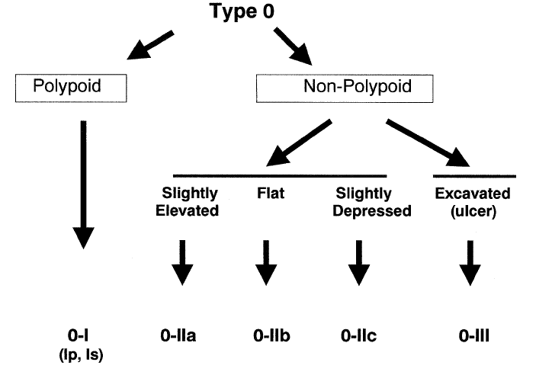
Figure 1: Neoplastic lesions with ‘superficial’ morphology. Reproduced with permission from Paris workshop participants (2003). The Paris endoscopic classification of superficial neoplastic lesions: oesophagus, stomach, and colon: November 30 to December 1, 2002. Gastrointest Endosc 58(6 Suppl):S3-43.¹

Reference
1 Participants in the Paris Workshop (2003). The Paris endoscopic classification of superficial neoplastic lesions: esophagus, stomach, and colon: November 30 to December 1, 2002. Gastrointest Endosc 58(6 Suppl):S3-43.

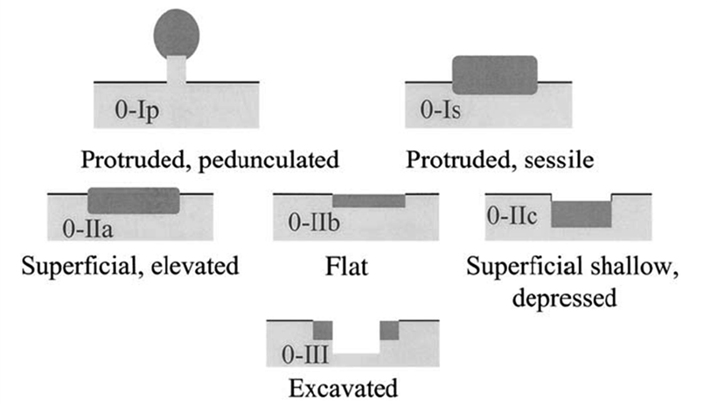
Figure 2: Schematic representation of the major variants of type 0 neoplastic lesions of the digestive tract: polypoid (Ip and Is), non-polypoid (IIa, IIb, and IIc), non-polypoid and excavated (III). Terminology as proposed in a consensus macroscopic description of superficial neoplastic lesions. Reproduced with permission from Paris workshop participants (2003). The Paris endoscopic classification of superficial neoplastic lesions: oesophagus, stomach, and colon: November 30 to December 1, 2002. Gastrointest Endosc 58(6 Suppl):S3-43.¹
Reference
1 Participants in the Paris Workshop (2003). The Paris endoscopic classification of superficial neoplastic lesions: esophagus, stomach, and colon: November 30 to December 1, 2002. Gastrointest Endosc 58(6 Suppl):S3-43.

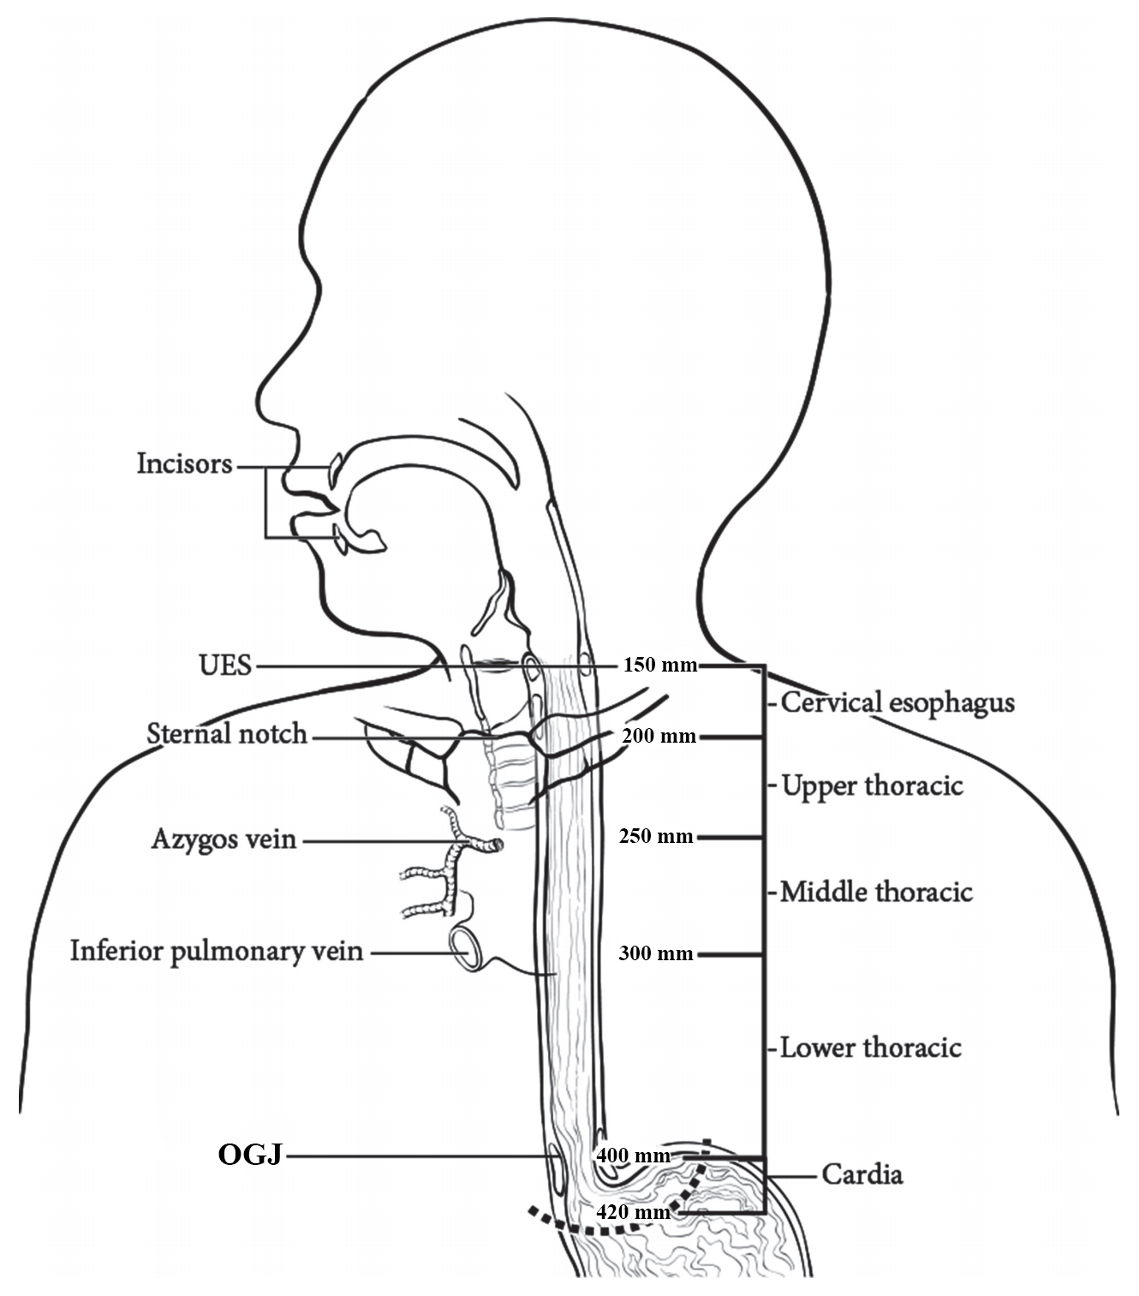
Figure 3: Anatomic subdivisions of the oesophagus. Modified with permission of the American College of Surgeons, Chicago, Illinois. The original source for this information is the American Joint Committee on Cancer Staging Manual, Eighth Edition (2016) published by Springer Science+Business Media.¹

Reference
1 Amin MB, Edge SB, Greene FL, Byrd DR, Brookland RK, Washington MK, Gershenwald JE, Compton CC, Hess KR, Sullivan DC, Jessup JM, Brierley JD, Gaspar LE, Schilsky RL, Balch CM, Winchester DP, Asare EA, Madera M, Gress DM and Meyer LR (eds) (2017). AJCC Cancer Staging Manual. 8th Edition, Springer, New York.

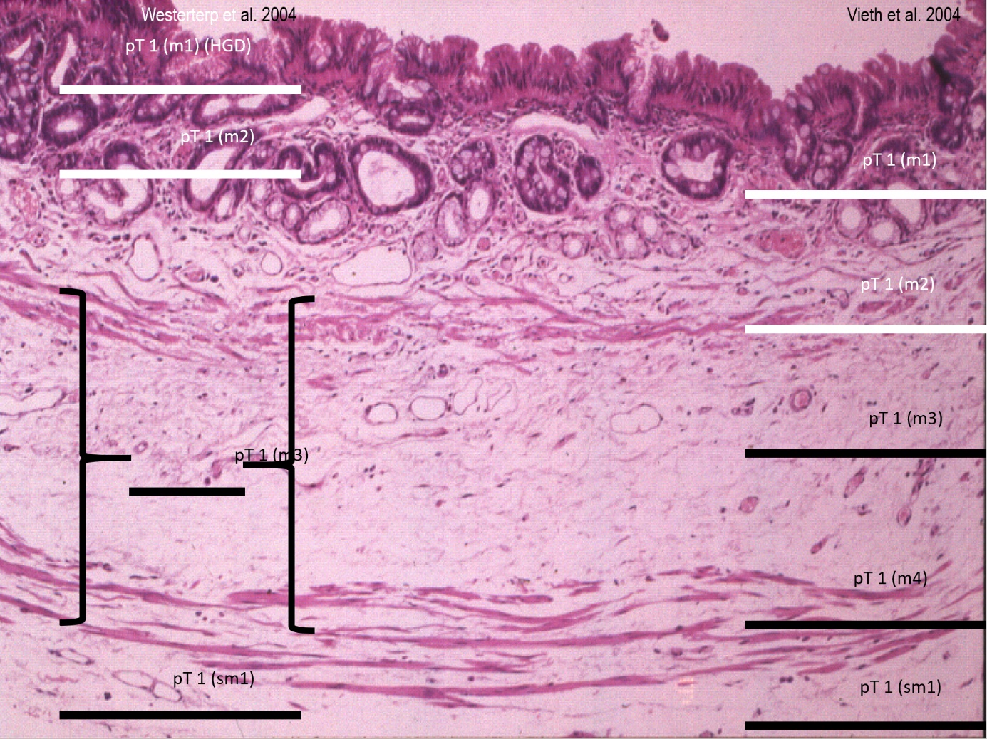
our dimension is important for documentation of the extent of the tumour

Figure 4: Subdivision of mucosal Barrett layer. Reproduced with permission from Vieth et al (2012). Barrett oesophagus. Practical issues for daily routine diagnosis. Pathology - Research and Practice 208(5):261-268.⁷

Reference
7 Vieth M, Langner C, Neumann H and Takubo K (2012). Barrett's esophagus. Practical issues for daily routine diagnosis. Pathol Res Pract 208(5):261-268.

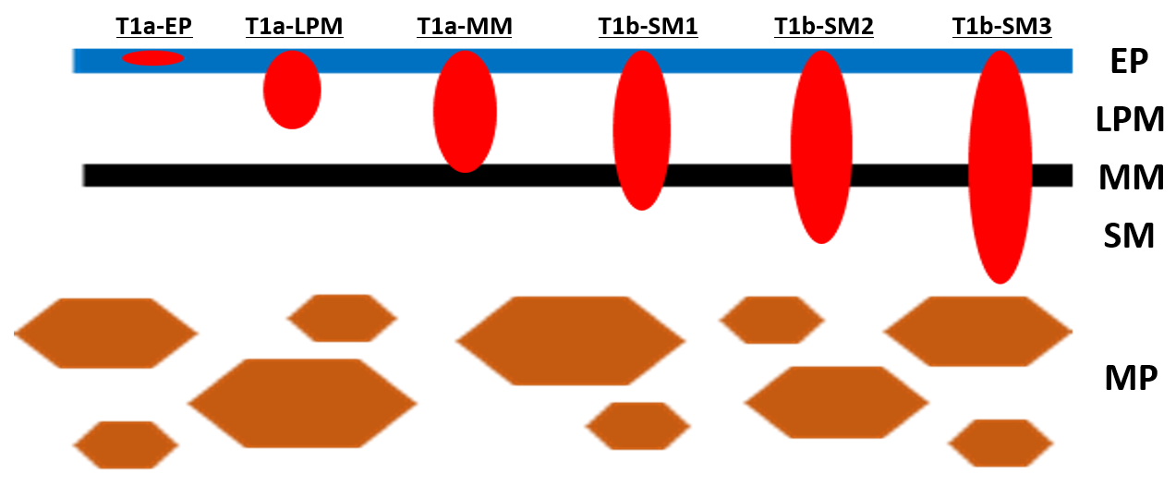
Figure 5: pT1 of intramucosal squamous cancer is assessed in the three stages: pT1-EP (epithelium), pT1a-LPM (lamina propria mucosae) and pT1a-MM (muscularis mucosae). The subclassification of pT1b is: pT1b-SM (submucosa) 1 for cancer cell invasion up to 200 μm and pT1b-SM2 for cancer cell invasion exceeding 200 μm; MP (muscularis propria). Modified with permission from Japan Esophageal Society (2017). Japanese Classification of Esophageal Cancer, 11th Edition: Part I. Esophagus 14:1–36.¹¹ Copyright © The Author(s) 2016. Open Access - This content is distributed under the terms of the Creative Commons Attribution 4.0 International License (http://creativecommons.org/licenses/by/4.0/)

Reference
11 Japan Esophageal Society (2017). Japanese Classification of Esophageal Cancer, 11th Edition: part I. Esophagus 14(1):1-36.

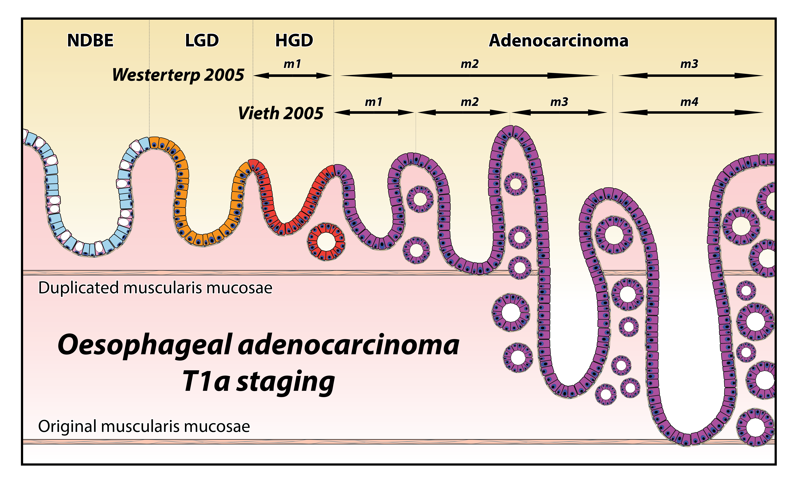
Figure 6: The two different systems of classification of the level of invasion of pT1a oesophageal adenocarcinoma). Permission courtesy of Dr Marnix Jansen.

Tables

Table 1: World Health Organization Classification of tumours of the oesophagus.⁶
Descriptor | ICD-O codesª
Benign epithelial tumours and precursors
Squamous cell papilloma NOS | 8052/0
Squamous papillomatosis | 8060/0
Oesophageal glandular dysplasia (intraepithelial neoplasia), low grade | 8148/0
Oesophageal glandular dysplasia (intraepithelial neoplasia), high grade | 8148/2
Oesophageal squamous intraepithelial neoplasia (dysplasia), low grade | 8077/0
Oesophageal squamous intraepithelial neoplasia (dysplasia), low grade | 8077/2
Malignant epithelial tumours
Adenocarcinoma NOS | 8140/3
Adenoid cystic carcinoma | 8200/3
Mucoepidermoid carcinoma | 8430/3
Adenosquamous carcinoma | 8560/3
Squamous cell carcinoma NOS | 8070/3
Verrucous squamous cell carcinoma | 8051/3
Squamous cell carcinoma, spindle cell | 8074/3
Basaloid squamous cell carcinoma | 8083/3
Carcinoma, undifferentiated, NOS | 8020/3
Lymphoepithelioma-like carcinoma | 8082/3
Neuroendocrine tumour NOS | 8240/3
Neuroendocrine tumour, grade 1 | 8240/3
Neuroendocrine tumour, grade 2 | 8249/3
Neuroendocrine tumour, grade 3 | 8249/3
Neuroendocrine carcinoma NOS | 8246/3
Large cell neuroendocrine carcinoma | 8013/3
Small cell neuroendocrine carcinoma | 8041/3
Mixed neuroendocrine–non-neuroendocrine neoplasm (MiNEN) | 8154/3
Combined small cell–adenocarcinoma | 8045/3
Combined small cell–squamous cell carcinoma | 8045/3
Mixed neuroendocrine carcinoma | 8244/3

ª These morphology codes are from the International Classification of Diseases for Oncology, Third Edition, second revision (ICD-O-3.2).⁷ Behaviour is coded /0 for benign tumours; /1 for unspecified, borderline, or uncertain behaviour; /2 for carcinoma in situ and grade III intraepithelial neoplasia; and /3 for malignant tumours, primary site; and /6 for malignant tumours, metastatic site. Subtype labels are indented. Incorporates all relevant changes from the 5th edition Corrigenda, September 2022.⁴
© World Health Organization/International Agency for Research on Cancer. Reproduced with permission.

Reference
4 WHO Classification of Tumours Editorial Board (2022). Digestive System Tumours, WHO Classification of Tumours, 5th Edition, Volume 1 - Corrigenda September 2022. Available from: https://publications.iarc.fr/Book-And-Report-Series/Who-Classification-Of-Tumours/Digestive-System-Tumours-2019 (Accessed 16th Feb 2023).
5 Lam AK (2018). Application of pathological staging in esophageal adenocarcinoma. Methods Mol Biol 1756:93-103.
6 Odze RD, Lam AK, Ochiai A and Washington MK (2019). Tumours of the oesophagus. In: Digestive System Tumours. WHO Classification of Tumours, 5th Edition., Lokuhetty D, White V, Watanabe R and Cree IA (eds), IARC Press, Lyon.
7 Fritz A, Percy C, Jack A, Shanmugaratnam K, Sobin L, Parkin DM and Whelan S (eds) (2020). International Classification of Diseases for Oncology, Third Edition, Second Revision ICD-O-3.2. Available from: http://www.iacr.com.fr/index.php?option=com_content&view=category&layout=blog&id=100&Itemid=577 (Accessed 17th November 2021).

Table 2: Intramucosal carcinoma (T1a) subclassification schemes.²⁻⁵
Depth of invasion | Vieth  et al 2005³ | Westerterp  et al 2005⁵ | Kaneshiro  et al 2011⁴ | AJCC 2017²
None - Tis, high grade dysplasia (HGD) | HGD | m1 | HGD | Tis
Tumour cells invade into lamina propria (LP) beyond the basement membrane | m1 | m2 | LP | T1a
Tumour cells invade inner duplicated muscularis mucosae (IMM) | m2 | m2 | IMM | T1a
Tumour cells in the space between the duplicated muscularis mucosae and original muscularis mucosae, i.e., between muscularis mucosae (BMM) | m3 | m2 | BMM | T1a
Tumour cells into outer original muscularis mucosae (OMM) | m4 | m3 | OMM | T1a

References
2 Amin MB, Edge SB, Greene FL, Byrd DR, Brookland RK, Washington MK, Gershenwald JE, Compton CC, Hess KR, Sullivan DC, Jessup JM, Brierley JD, Gaspar LE, Schilsky RL, Balch CM, Winchester DP, Asare EA, Madera M, Gress DM and Meyer LR (eds) (2017). AJCC Cancer Staging Manual. 8th Edition, Springer, New York.
3 Vieth M and Stolte M (2005). Pathology of early upper GI cancers. Best Pract Res Clin Gastroenterol 19(6):857-869.
4 Kaneshiro DK, Post JC, Rybicki L, Rice TW and Goldblum JR (2011). Clinical significance of the duplicated muscularis mucosae in Barrett esophagus-related superficial adenocarcinoma. Am J Surg Pathol 35(5):697-700.
5 Westerterp M, Koppert LB, Buskens CJ, Tilanus HW, ten Kate FJ, Bergman JJ, Siersema PD, van Dekken H and van Lanschot JJ (2005). Outcome of surgical treatment for early adenocarcinoma of the esophagus or gastro-esophageal junction. Virchows Arch 446(5):497-504.

